**CHAPTER FOUR**

**SYSTEM DESIGN AND IMPLEMENTATION**

This chapter presents the system specifications design and implementation which comprise the objectives of the design and the requirements of the system proposed.

**4.1 System Design**

The design of the proposed system is an important aspect of the system to achieve the desired aim and objectives. In view of this, the design provides a blueprint of how the input, processing and output components are progressively integrated.

The proposed system is designed to achieve the following objectives:

1. It allows the cafeteria management to modify the food information such as price, add a new menu and many others as well as for managing user, system menu and promotion records.
2. To build a platform that conveniently assists customers with issues or complaints concerning the food ordering process.

The system architecture of the proposed system can be found in the figure 2.0 below:

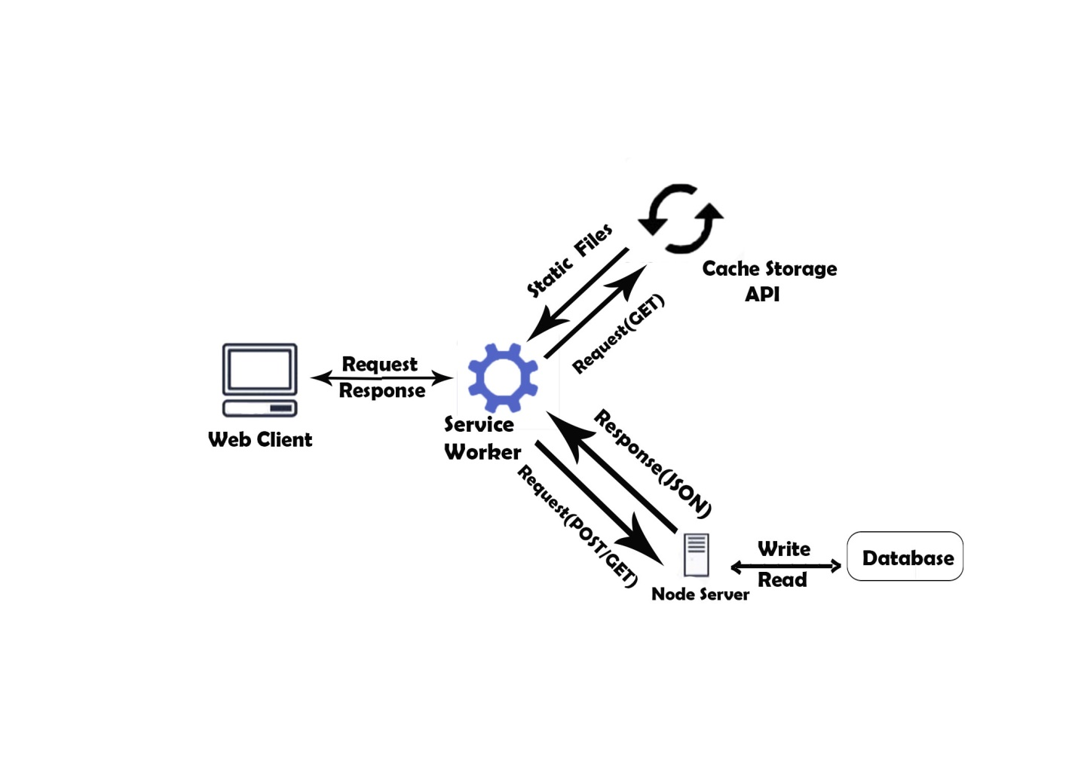

Figure 2.0 The system architecture of the proposed system.

**4.1.1 Database Design**

The database schema for the proposed solution is represented as the following:

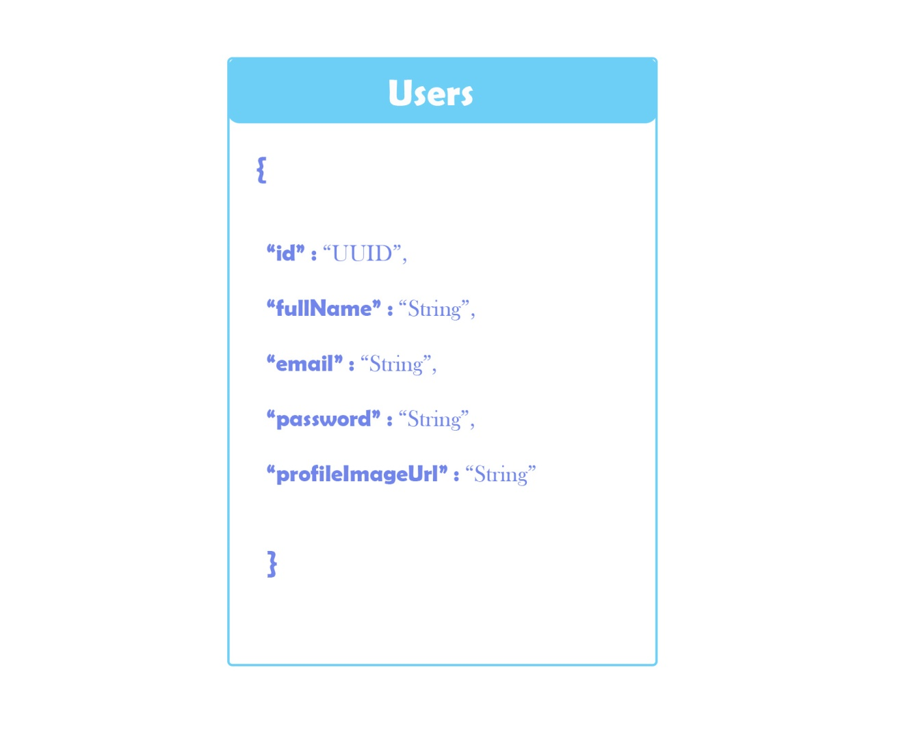

Figure 3.0 A Schema for Users Collection

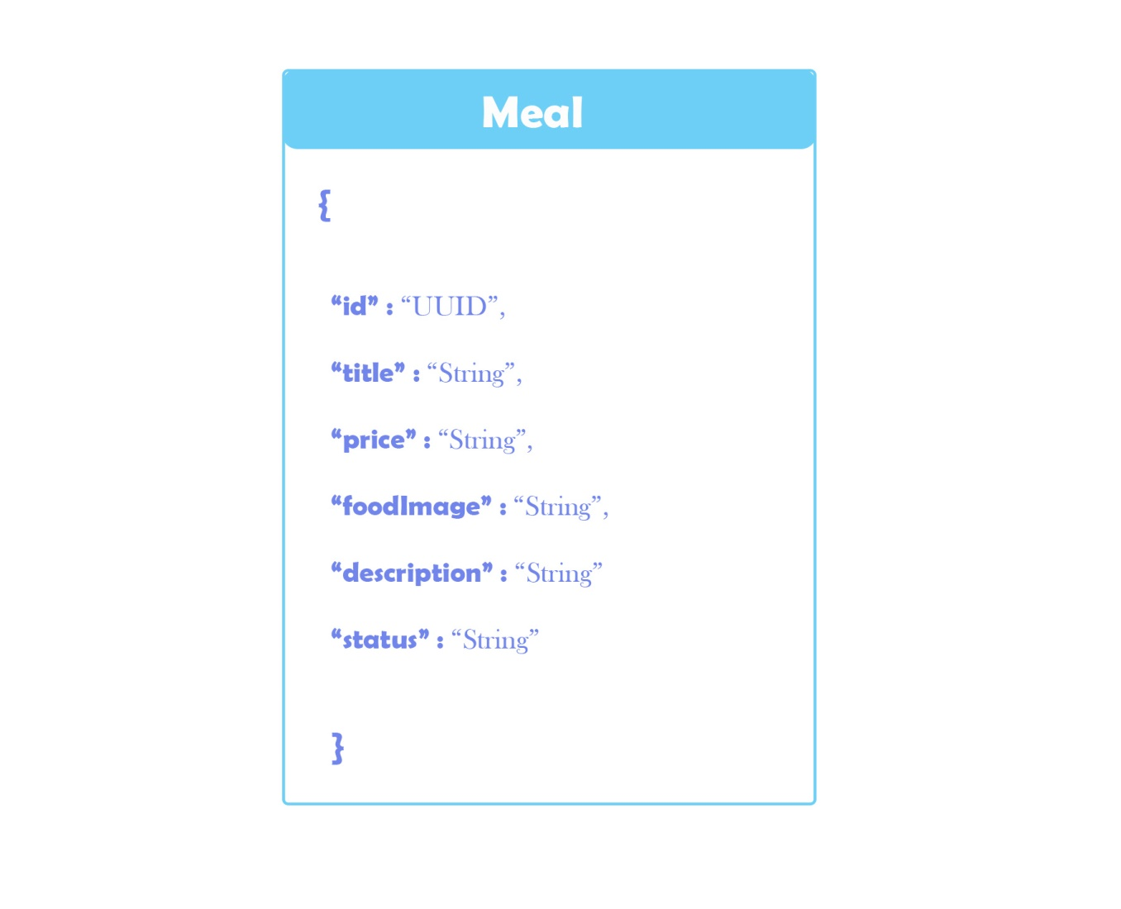

Figure 4.0 A Schema for Meal Collection

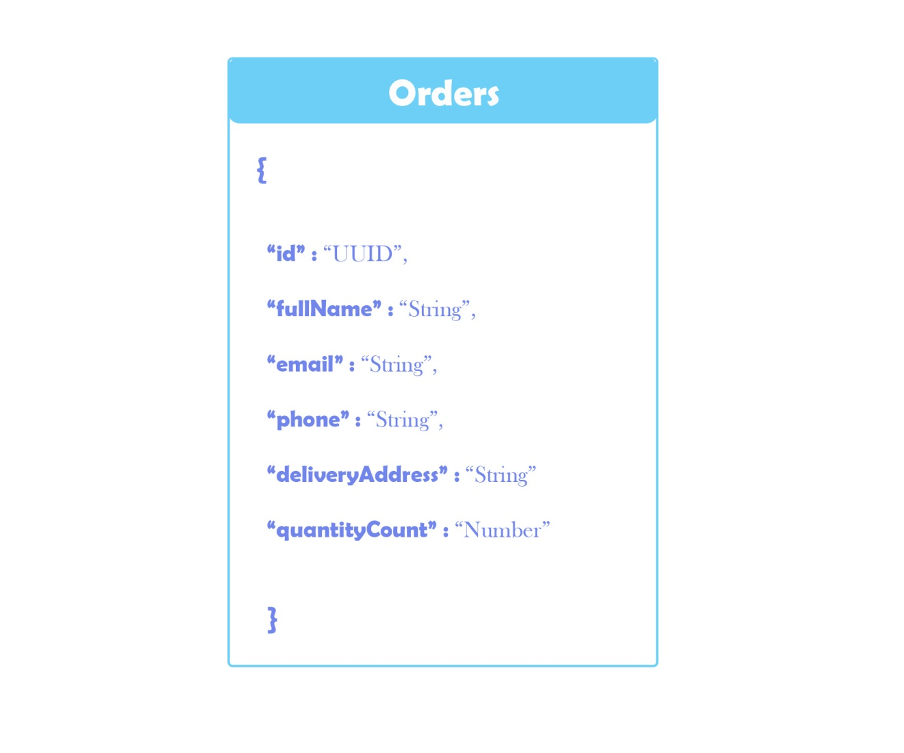

Figure 5.0 A Schema for Order Collection

**4.1.2 User Interface Design**

The proposed system interface designs are as follows:

1. Login Interface

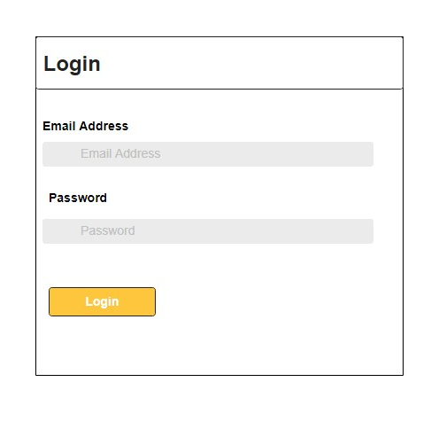

Fig 6.0 Wireframe design for Login Page

1. Home page Interface



Fig 7.0 Wireframe design for Home page Interface

1. Order meal Interface

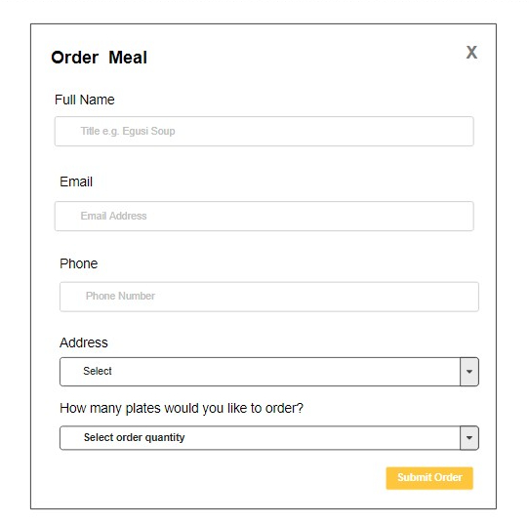

Fig 8.0 Wireframe design for Order meal page Interface

1. Create meal Interface

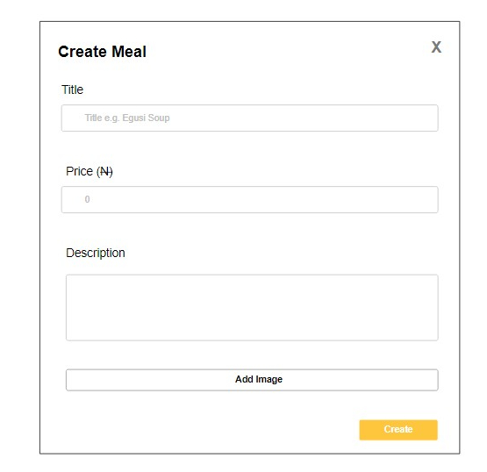

Fig 9.0 Wireframe design for Create meal page Interface

1. Order page Interface

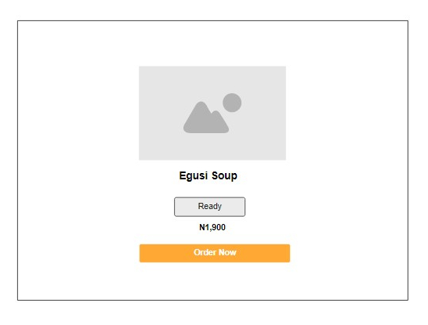

Fig 10.0 Wireframe design for Order page Interface

1. Dashboard Search page Interface

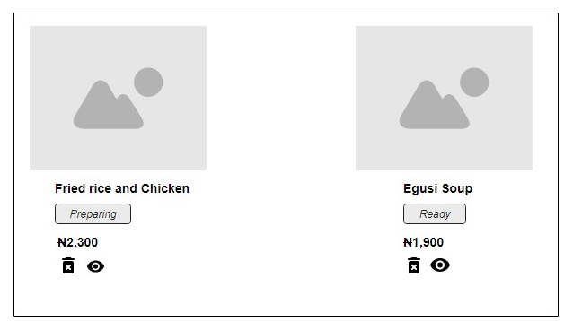

Fig 11.0 Wireframe for Dashboard Search page Interface

**4.1.3 Subsystem / Program modules design**

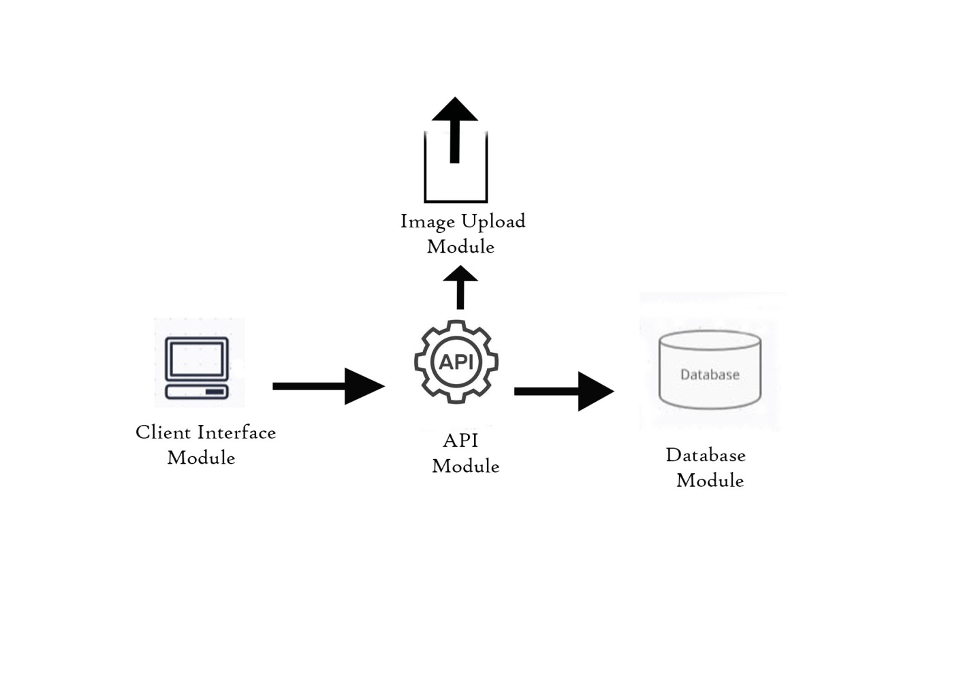

Fig 12.0 Wireframe for Subsystem / Program modules.

**4.2 System Implementation**

The application is titled; Food Wagon. In the database design of the application, the most significant database objects for storing information are collections. The built-in procedures are carefully crafted queries that do one of these tasks; Insertion, update, delete. Certain built-in methods are triggered as users interact with the application, causing certain changes or returning a dataset to the client.

**4.2.1 Choice of implementation tools and platform**

1. Backend Runtime Environment is with Nodejs
2. Backend Server is with express js
3. Backend codes with Javascript
4. Backend Data caching is with Redis
5. Frontend Framework is with React js
6. Front end languages is HTML, CSS, Javascript
7. Database DBMS is with MySQL database
8. Client-Server sync is with firebase functions.

**4.2.2 Database Implementation**

The database of the proposed system is implemented using MySQL database. MySQL is a relational database management system based on SQL – Structured Query Language. The application is used for a wide range of purposes, including data warehousing, e-commerce, and logging applications.

The most common use for MySQL however, is for the purpose of a web database. It can be used to store anything from a single record of information to an entire inventory of available products for an online store.

**4.2.3 User Interface Implementation**

**a) Login Phase**

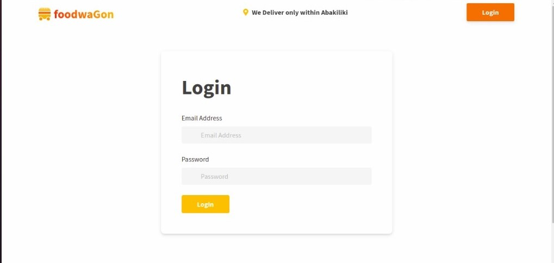

**b) Order page phase**

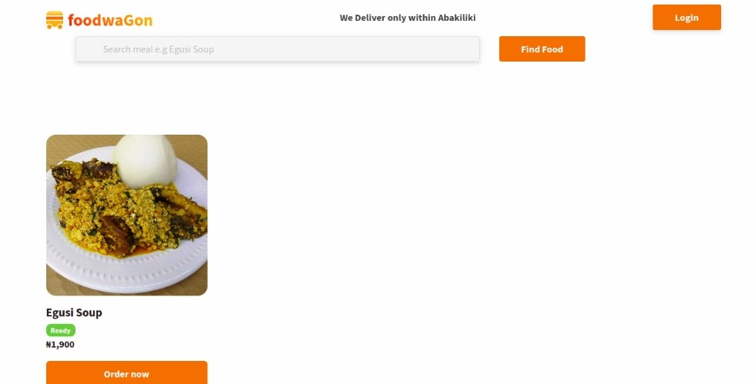

**c) Create meal Interface**

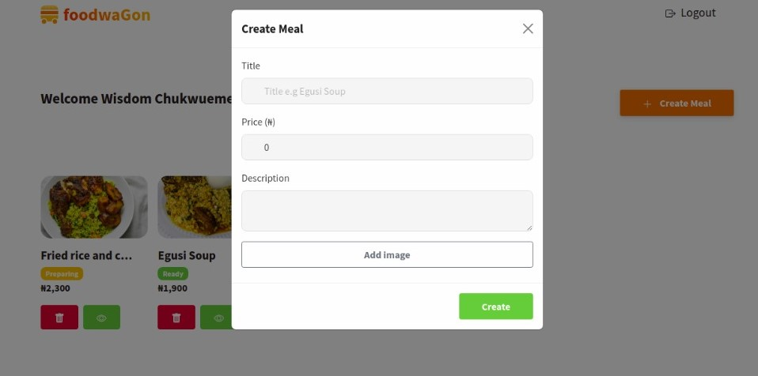

**d) Dashboard search page Interface**

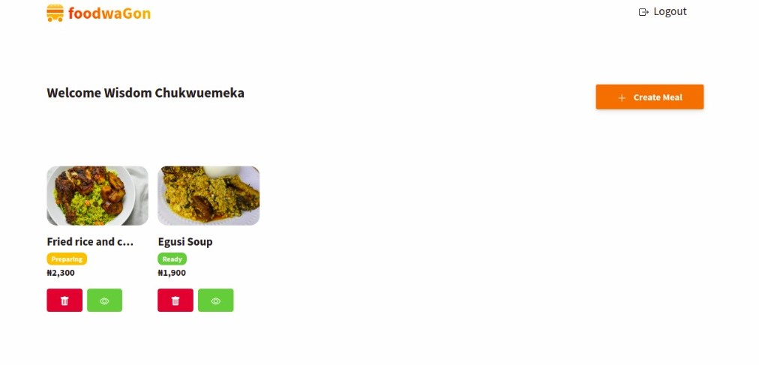

**e) Order meal Interface**

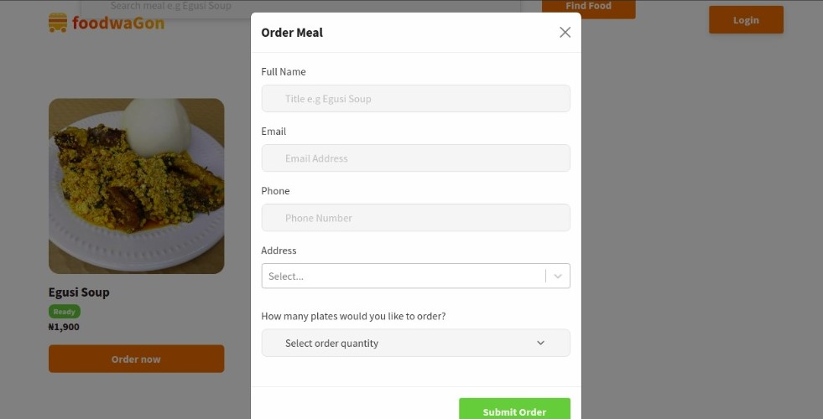

**f) Profile Interface**

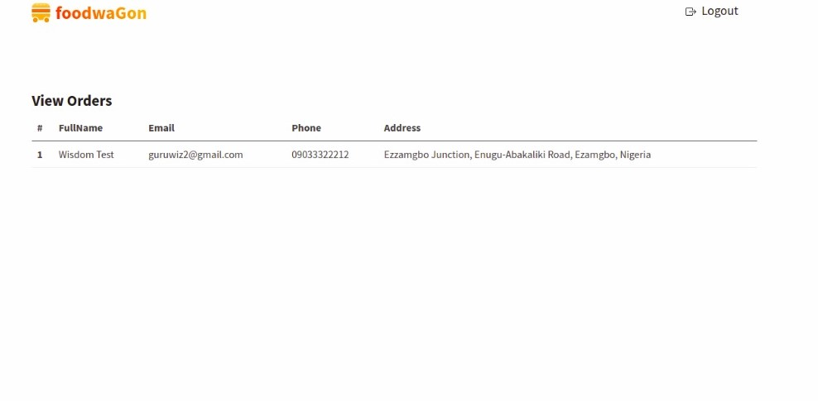

**g) Home Interface**



**4.2.4 Subsystems / Modules Implementation**

**a) Client Interface Module**

The client interface module contains visual elements or widgets which enables the user to easily interact with the application. The client interface module is built with front-end web development languages and frameworks like HTML, CSS, Javascript and React. The client module consist of several progressive components built independently to communicate with each other via a communication service called props.

**b) Database Module**

This module comprises all the essential services required to store, retrieve and manage data from the database. It includes middlewares, Database management systems (DBMS), queries and Database models.

**c) API Module**

This module contains the language and message format used by an application program to communicate with the operating system or some other control program such as database management system (DBMS) or communications protocol.

**d) Image Upload Module**

This image upload module enables one to upload images and to manage these uploads if given the appropriate permissions. This module also tracks and manages all image references.